Dark Destiny.co.uk

Visitors Guide to Brompton Cemetery

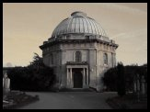

Brompton Cemetery – Old Brompton Road, London SW10 9UG

Brompton Cemetery was opened in 1840 by the “West of London and Westminster Cemetery Company”. The 39 acre plot of land acquired for the cemetery had previously been occupied by brickworks and a market garden. Due to the plot being geographically featureless it was decided that in order to compete with the rolling landscapes of Nunhead and Highgate the cemetery would be a spectacular display of architecture.

It was therefore decided to build Brompton to be representative of a large symmetrical outside cathedral. The full extent of Brompton’s architectural superiority however was never realised. The building costs escalated to over double the initial estimate and legal disputes with the building company resulting in Brompton remaining unfinished.

Notables Buried in Brompton

Walter Lacy, Percy Lambert, Joseph Henry Irving, Sir Samuel Cunard, Dr Benjamin Golding, Michael Madden, Henry Alfred Pettit, Samuel Leigh Sotheby, Brandon Thomas, Sir Thomas Spencer Wells

Opening Times

Summer - 8.00am to 8.00pm

Winter – 8.00am to 4.00pm

Tours

Tours of Brompton Cemetery take place on the 2nd and 4th Sunday of each month, please call the Chapel Office before travelling for confirmation: +44 (0)20 7352 1201, continued on next page -

© DarkDestiny.co.uk

Tours continued:

The tours take place regardless of weather and include the inside of the chapel (the catacombs can only be viewed on the annual open day).

A £3.00 donation is requested per person, any accompanied children go free.

Meet at the South Lodge beside the Fulham Road Gate at 2.00pm.

Travel

West Brompton tube station on the District Line is a short walk from the main gate.

Buses are - 14, 74, 190, 211, 328, 414, 430, C1, C3

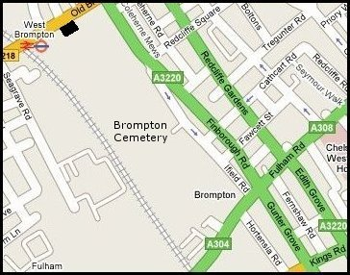

Dark Destiny.co.uk

London’s Magnificent Seven

© Dark Destiny.co.uk

All information subject to change

