Dark Destiny.co.uk

Visitors Guide to Highgate Cemetery



Highgate Cemetery - Swains Lane, Highgate, London N6 6PJ

The West Cemetery was opened in 1839 and the East Cemetery in 1854.

Notables Buried in Highgate

East Highgate – Karl Marx, George Eliot, William Foyle, Max Wall, Henry Moore, William Monk, Robert Thoms

West Highgate – Michael Faraday, Charles Cruft, Catherine Dickens, Rossetti/Siddal, Julius Beer, Ellen Wood, Thomas Sayers, Carl Rosa, Radclyffe Hall

Opening Times

Open everyday except the 25th and 26th of December.

East Cemetery – Opens at 10am weekdays and 11am weekends. Closing time is 5pm 1st April to 31st October (last admission 4.30pm) and 4pm 1st November to 31st March (last admission 3.30pm).

Entry is £3.00 per adult which now includes a camera permit; children under 16 accompanied by an adult are free.

There is a guided tour of the East Cemetery once a month, on the first Saturday of each month. Tours are about one hour in length, and are limited to 15 people. Tickets are sold at the East Cemetery gate on the day of the tour on a first come, first served basis. The tour cost of £5 includes entrance to the East Cemetery.

West Cemetery – Admission is by guided tour only.

Weekday Tours – One tour daily which starts at 2pm, booking is advisable on (+44) 020 8340 1834. There are no weekday tours during December, January and February.

Weekend Tours – Take place every hour at 11am, 12noon, 1pm, 2pm, 3pm and 4pm, (last tour is at 3pm from 1st November to 31st March). There is no booking at weekends, please arrive early.

Ticket Prices are £5.00 per person (Includes photo permit), children under the age of eight are not permitted on tours.

Travel

Parking is limited so public transport is advisable.

Tube train – Take the Northern Line to Archway station (not Highgate) then walk or bus up Highgate Hill, buses are 271, 210 or 143, set down at Lauderdale House. Then walk through Waterlow Park to Swains Lane.

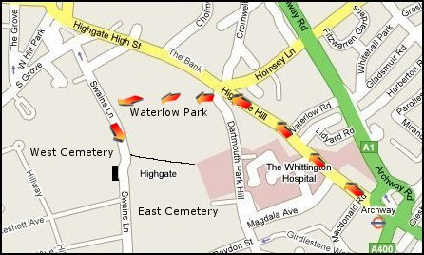

Dark Destiny.co.uk

London’s Magnificent Seven

© Dark Destiny.co.uk

All information subject to change

