Dark Destiny.co.uk

Visitors Guide to Nunhead Cemetery

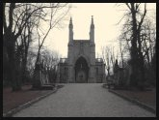

Nunhead Cemetery – Linden Grove, London SE15

All Saints Cemetery at Nunhead was opened for burials in 1840. Nunhead was built and originally owned by “The London Cemetery Company” who also owned and ran Highgate Cemetery which opened the previous year.

The Cemetery was abandoned in 1969 when ever increasing maintenance costs and a down turn in income made the Cemetery unsustainable. Until Southwark Council acquired the cemetery in 1975 it was left to the ravages of nature. Unfortunately during that time the cemetery also suffered extensive vandalism including the desecration of the Crypt and Catacombs along with an arson attack on the Anglican chapel.

Today Nunhead is managed jointly by the council’s park rangers in association with the Friends of Nunhead Cemetery.

Notables Buried in Nunhead

Frederick Augustus Abel, Charles Abbott, Alfred Vance, Jenny Hill, Frederick Gorring, Commander John Jones, George England, Albert Collcott, Augustus Durandeau, Julio H Hughes, Ambrose Maynard, Marie Tyler, Edward Weston

Opening Times

April 1st to September 30th – 8.00am to 7.00pm daily

October 1st to March 31st – 8.00am to one hour before sunset

Tours

The Friends of Nunhead Cemetery hold one tour on the last Sunday of each month. Tours start at 2.15pm from the Linden Grove gates; they last for about 2 hours and are free of charge.

© DarkDestiny.co.uk
Travel

The nearest railway station is Nunhead. From central London trains run on average twice an hour at weekends (more on weekdays) from Victoria mainline station. The Journey time is between 14 to 18 minutes and the walk from the train station to Nunhead Cemetery is about 10 minutes.

Buses – numbers 343 and P12 run to the cemetery.

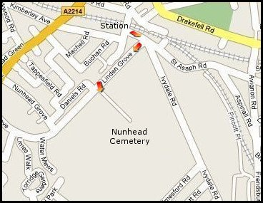

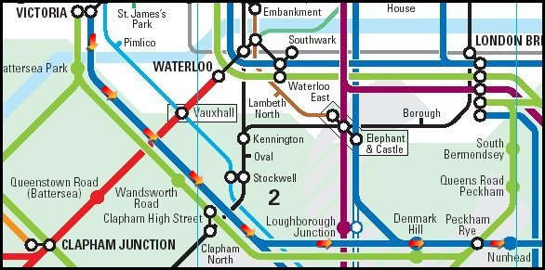

Dark Destiny.co.uk
London’s Magnificent Seven
© Dark Destiny.co.uk
All information subject to change

