Dark Destiny.co.uk

Visitors Guide to Tower Hamlets Cemetery

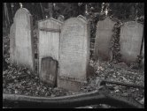

Tower Hamlets Cemetery - Southern Grove, London E3 4PX

The City of London and Tower Hamlets Cemetery was opened in 1841. The Cemetery occupied 27 acres of land and was extremely popular with the east end Victorians.

By 1851 80% of burials were made in public graves which were owned by the Cemetery Company and made available to those to poor to pay for a funeral. These public graves contained multiple burials and it is believed that some graves were dug to depths as deep as 40 feet and contained as many as 30 bodies.

The Cemetery fell victim to World War II and was bombed five times; some headstones still exhibit the scars of shrapnel damage to this day. In 1966 the Greater London Council (GLC) brought the Cemetery for £100,000 and then closed it for burials. The G.L.C then spent a further £125,000 in 1967 demolishing the bomb damaged chapels and clearing graves.

While many monuments still remain, Tower Hamlets Cemetery is better known today as a nature reserve which provides a valuable retreat in the crowded east end.

Notables Buried in Tower Hamlets

Dr Rees Ralph Llewellyn, Alexander Hurley, John “White Hat” Willis, Marie Lloyd, Alfred Linnel, Will Crooks, Hannah Maria Purcell, Captain John Chrystal, Henry Orbell.

Opening Times – Admission Free

The main gates in Southern Grove are open between 8.00am and dusk or 9.00pm which ever is soonest depending on season.

The kissing gates at all other points remain open at all times.

© DarkDestiny.co.uk
Tours

The Friends of Tower Hamlets Cemetery hold many different events throughout the year including nature walks, recording and researching of grave memorials and their annual open day.

For more details please telephone - 07904 186 981 or consult their website at www.towerhamletscemetery.org or call the Soanes Centre on 020 8252 6644

Travel

The nearest underground station is Mile End on the Central, District and Hammersmith and City lines.
Local bus routes are: D6, D7, 25, 277 and 339.

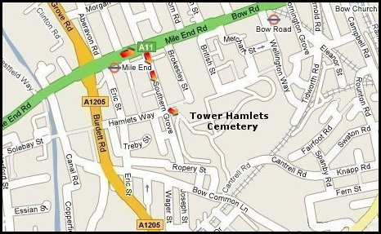

Dark Destiny.co.uk

London’s Magnificent Seven

© Dark Destiny.co.uk

All information subject to change

