Dark Destiny.co.uk

Visitors Guide to West Norwood Cemetery

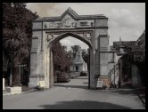

West Norwood Cemetery – Norwood Road, London SE27 9JU

West Norwood Cemetery was consecrated by the Bishop of Winchester on December 7th 1837. It was the first Cemetery in the UK to be designed in the new Gothic style.

At the time its rural setting in open countryside attracted the attention of the wealthy Victorian’s who commissioned many fine mausoleums and memorials for their burial plots and vaults. West Norwood originally included two Gothic Chapels at the crest of the hill; unfortunately these were both badly damaged by bombs in World War II. The Dissenters Chapel was rebuilt as a crematorium while the Episcopal Chapel was leveled and a memorial garden now stands over the still remaining Catacombs.

In 1842 a section of West Norwood was acquired for a Greek Orthodox cemetery. Today this section remains filled with some fine Mausoleums, Monuments and the impressive St Stephens Chapel.

Notables Buried in West Norwood

Sir Henry Tate, Paul Julius Baron von Reuter, Sir Henry Doulton, Mrs Beeton, Sir Henry Bessemer, Dr William Marsden, Revd Charles Spurgeon

Opening Times – Admission Free

November to March:

Weekdays 8am to 4pm, Weekends & Bank Holidays 10am to 4pm, Christmas Day 10am to 2.30pm

April to October:

Weekdays 8am to 6pm, Weekends & Bank Holidays 10am to 6pm

© DarkDestiny.co.uk
Tours

The Friends of West Norwood Cemetery hold guided tours on the first Sunday of every month at 2.30pm April-October and at 11am November-March. Cemetery tours start at the Cemetery Main Gate, Norwood Road SE27.

There is no formal charge for any tour, but donations of £1 per person (£0.50 concessions) to help cover costs and aid conservation work are appreciated.

Travel

The nearest railway station is West Norwood, which is a five minute walk from the Cemeteries main gate. From central London trains run frequently from Victoria Main Line Station.

Buses 2, 68, 196, 315, 322 and 468 all stop outside the Cemetery.

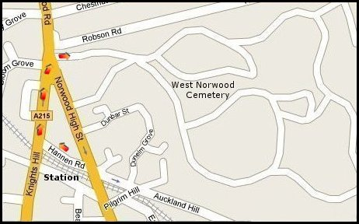

Dark Destiny.co.uk
London’s Magnificent Seven

© Dark Destiny.co.uk

All information subject to change

